4th Step Using Loop for training the data set

When I do 1st, 2nd and 3rd steps it all ways trained data set and optimize trained and tested data set in before step. That step is trained and tested the data set in one time and get their accuracy in one time. That is not enough to check and get perfect accuracy in data sets. So, I created the loop for testing and training datasets.

1st I loaded before I get Accuracies and their result and defined for loop evaluation training data in 10 times using mergedData.mat file. Then defined the normalization, training and testing validation and accuracy calculating part and displaying values in command window part created inside for loop. Finally save the all training and testing accuracy in one file like all_results.mat file.

The code is mentioned below.

% Initialize an array to store results for each iteration

train_accuracies = zeros(10, 1); % Store training accuracies

test_accuracies = zeros(10, 1); % Store test accuracies

all_results = cell(10, 1); % Store results for each iteration

% Run the training and evaluation 10 times

for i = 1:10

fprintf('Iteration %d of 10\n', i);

% Load the merged dataset

load('mergedData.mat');

% Separate features and targets

inputs = merged_data(:, 1:end-1)'; % Features (transpose to match NN input format)

targets = merged_data(:, end)'; % User identifiers/targets (transpose for NN format)

% Normalize the input data

inputs = normalize(inputs, 'range'); % Normalize to [0, 1] range

% Create and configure the neural network

hiddenLayerSize = [20, 10]; % Define hidden lauer size

net = feedforwardnet(hiddenLayerSize, 'trainlm'); % Feedforward NN with Levenberg-Marquardt algorithm

% Divide data into training, validation, and test sets

net.divideParam.trainRatio = 0.7; % 70% training

net.divideParam.valRatio = 0.15; % 15% validation

net.divideParam.testRatio = 0.15; % 15% testing

% Set training parameters

net.trainParam.epochs = 1000; % Maximum number of epochs

net.trainParam.goal = 1e-6; % Performance goal (MSE)

net.trainParam.min_grad = 1e-7; % Minimum gradient

% Train the neural network

[net, tr] = train(net, inputs, targets);

% Evaluate training accuracy

train_outputs = net(inputs(:, tr.trainInd)); % Network predictions for training set

train_predicted_classes = round(train_outputs); % Round predictions to nearest integer

train_actual_classes = targets(tr.trainInd); % Actual training targets

% Calculate training accuracy

train_correct_predictions = sum(train_predicted_classes == train_actual_classes);

train_total_samples = length(train_actual_classes);

train_accuracy = (train_correct_predictions / train_total_samples) * 100;

train_accuracies(i) = train_accuracy; % Store training accuracy

% Evaluate test accuracy

test_inputs = inputs(:, tr.testInd); % Inputs for the test set

test_targets = targets(tr.testInd); % Targets for the test set

% Generate predictions for the test set

test_outputs = net(test_inputs);

test_predicted_classes = round(test_outputs);

test_actual_classes = test_targets;

% Calculate test accuracy

test_correct_predictions = sum(test_predicted_classes == test_actual_classes);

test_total_samples = length(test_actual_classes);

test_accuracy = (test_correct_predictions / test_total_samples) * 100;

test_accuracies(i) = test_accuracy; % Store test accuracy

% Store the results for each iteration

results.train_accuracy = train_accuracy; % Training accuracy

results.test_accuracy = test_accuracy; % Test accuracy

results.net = net; % Trained neural network

results.training_record = tr; % Training record (training, validation, test performance)

% Save the results for each iteration

save(sprintf('trained_results_%d.mat', i), 'results'); % Save results for each iteration

fprintf('Iteration %d: Training Accuracy = %.2f%%, Test Accuracy = %.2f%%\n', i, train_accuracy, test_accuracy);

end

% Save all iteration results

save('all_results.mat', 'train_accuracies', 'test_accuracies', 'all_results');

% Print final message

fprintf('Training and testing completed for 10 iterations. Results saved.\n');

When I run that code I get result like below

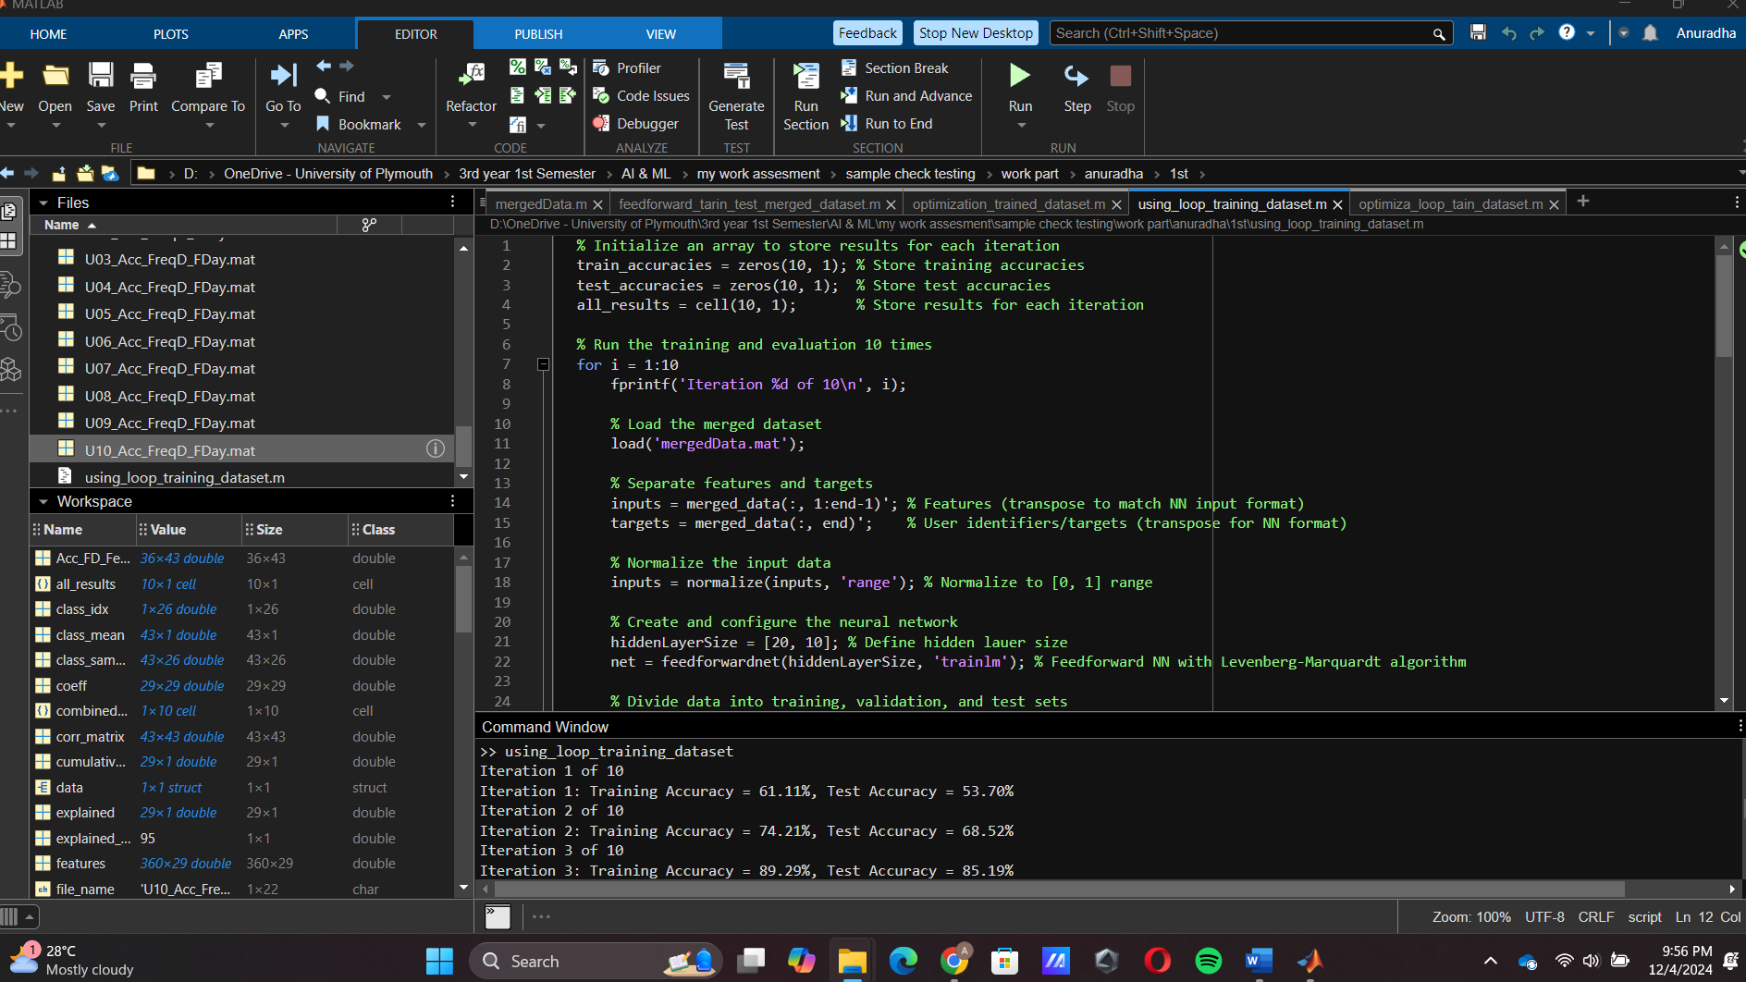

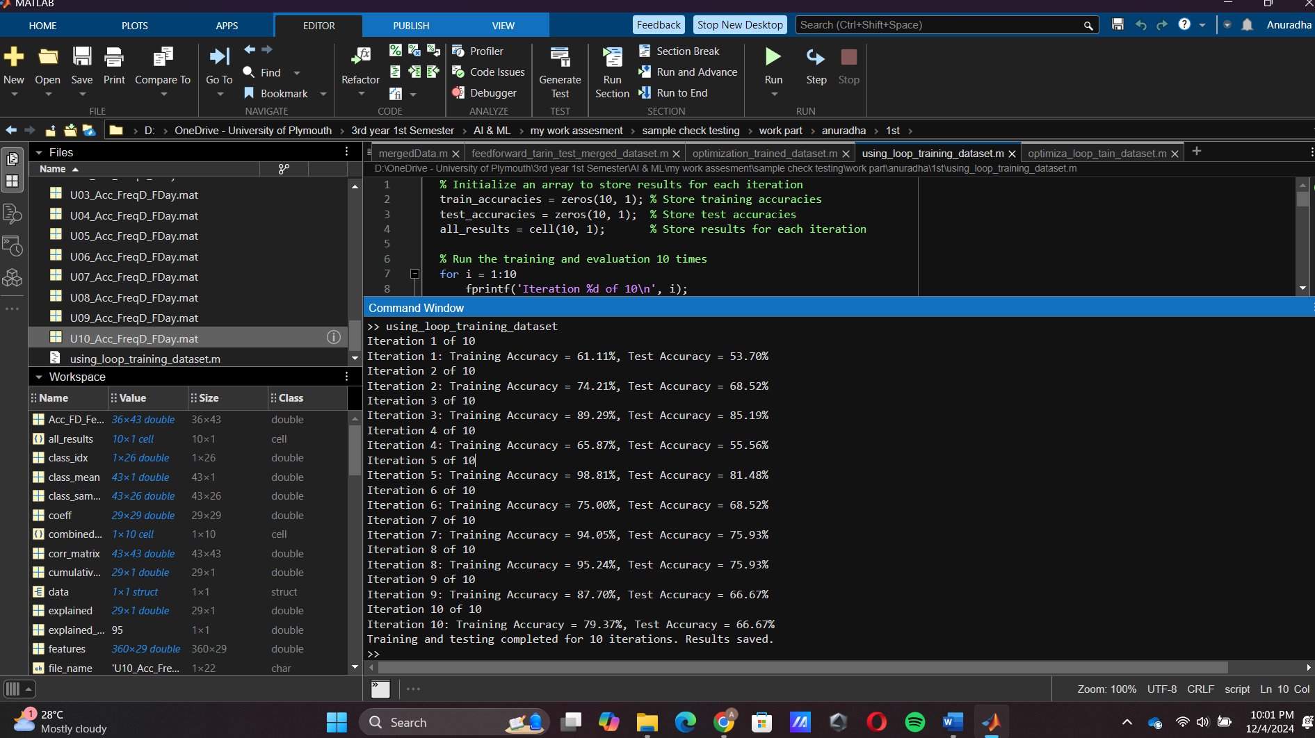

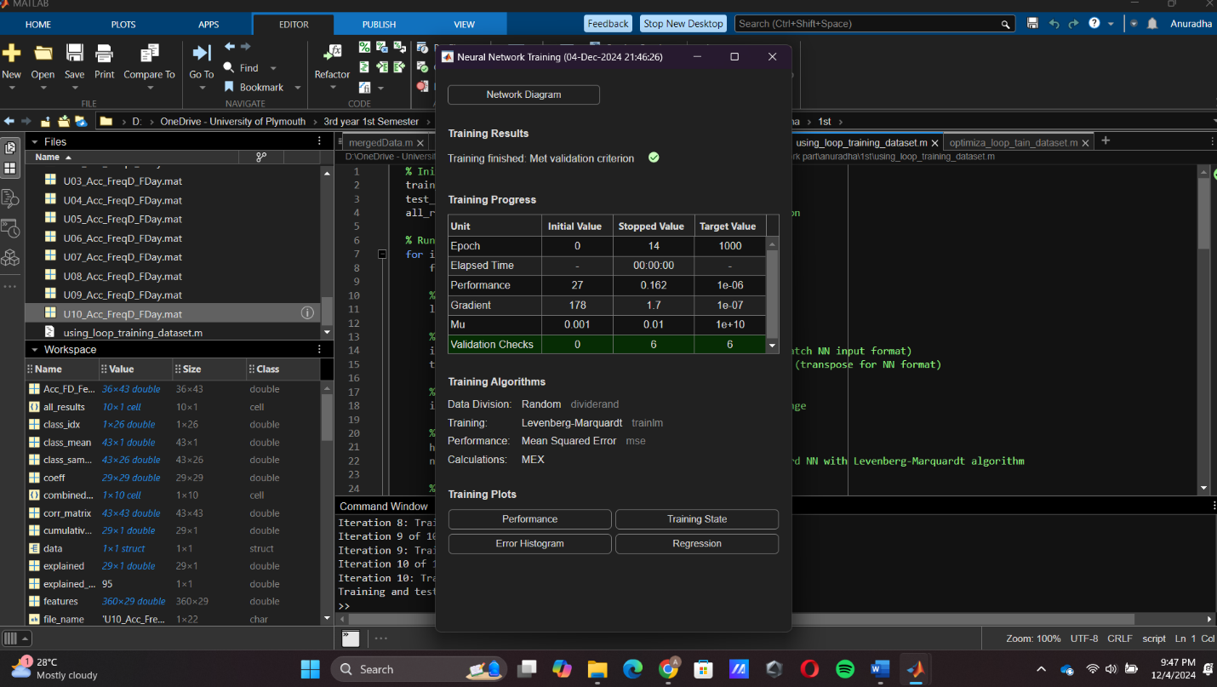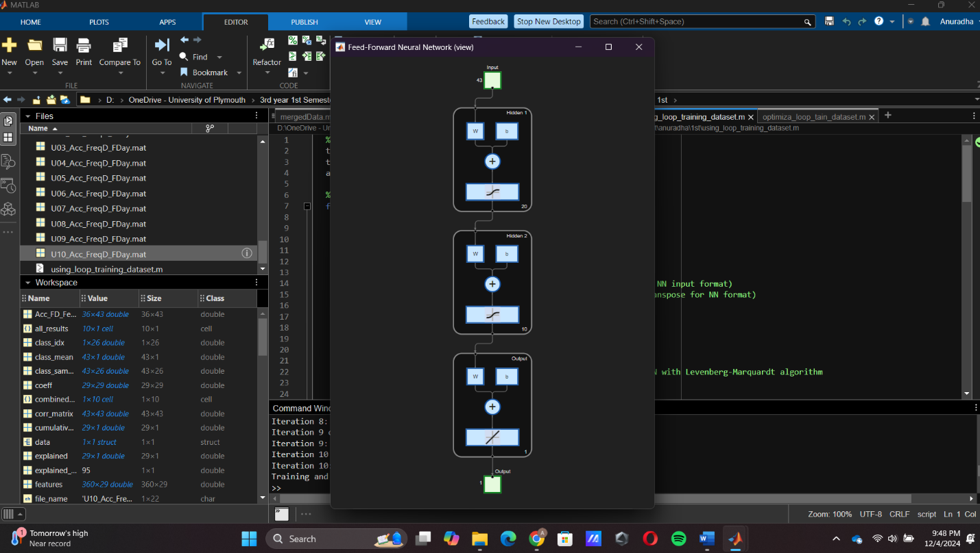

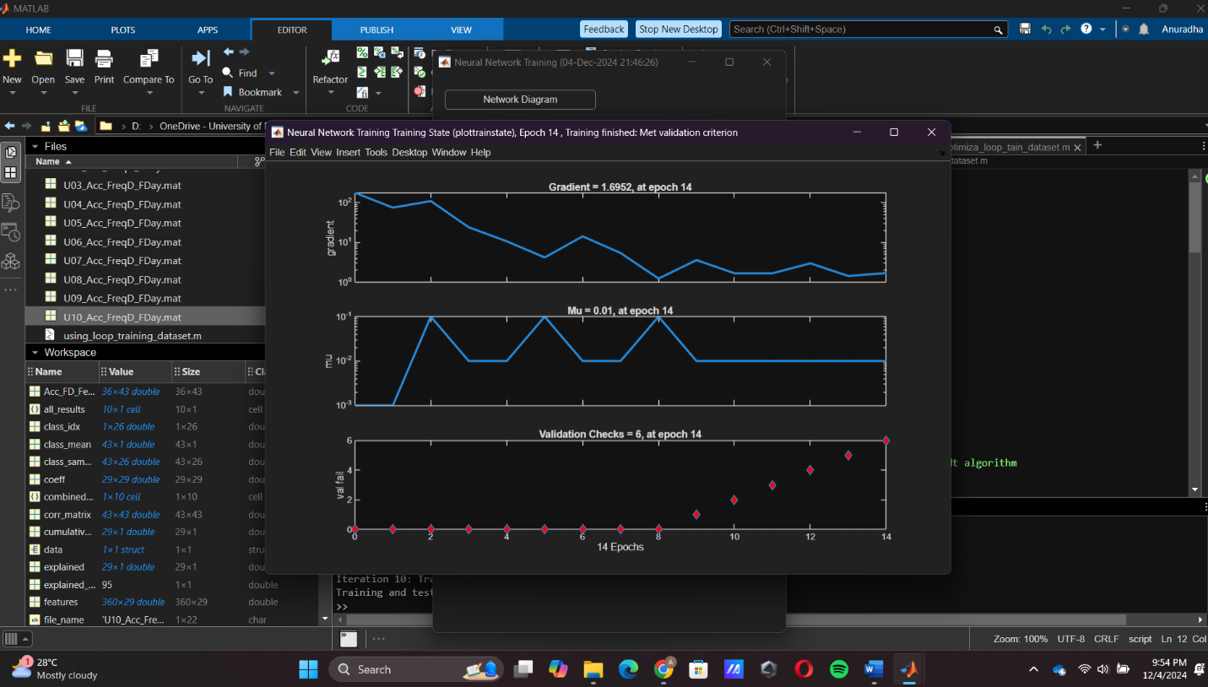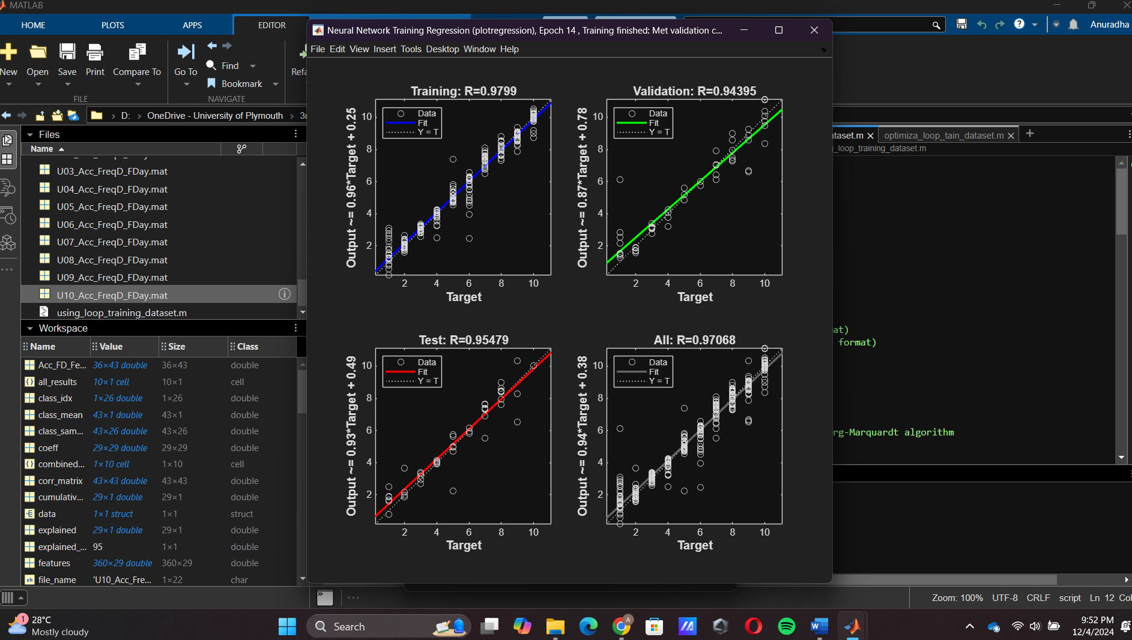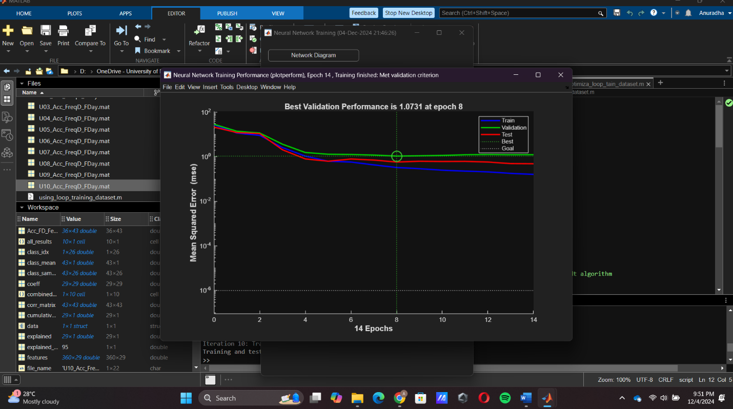

When I use the loop, I can test that dataset many times and can get the more valued accuracy in that data set.

I give above code I forget the get the average training accuracy in 10-time training accuracy in data set. But it already gets the 10 time trained data set and their accuracy and based on that, the average value of the data set can be calculated based on a manual method.

Then I test the data set with different hidden layer size and adjust the proportions of data allocated to training, validation, and testing in data Division ratios and changing training parameters can get the different valuers for testing ad training.

2nd time trained

1st changing only hidden layers size [20,10] to [30,15], the results given below.

Changed code part,

% Create and configure the neural network

hiddenLayerSize = [30, 15]; % Define hidden lauer size

net = feedforwardnet(hiddenLayerSize, 'trainlm'); % Feedforward NN with Levenberg-Marquardt algorithm

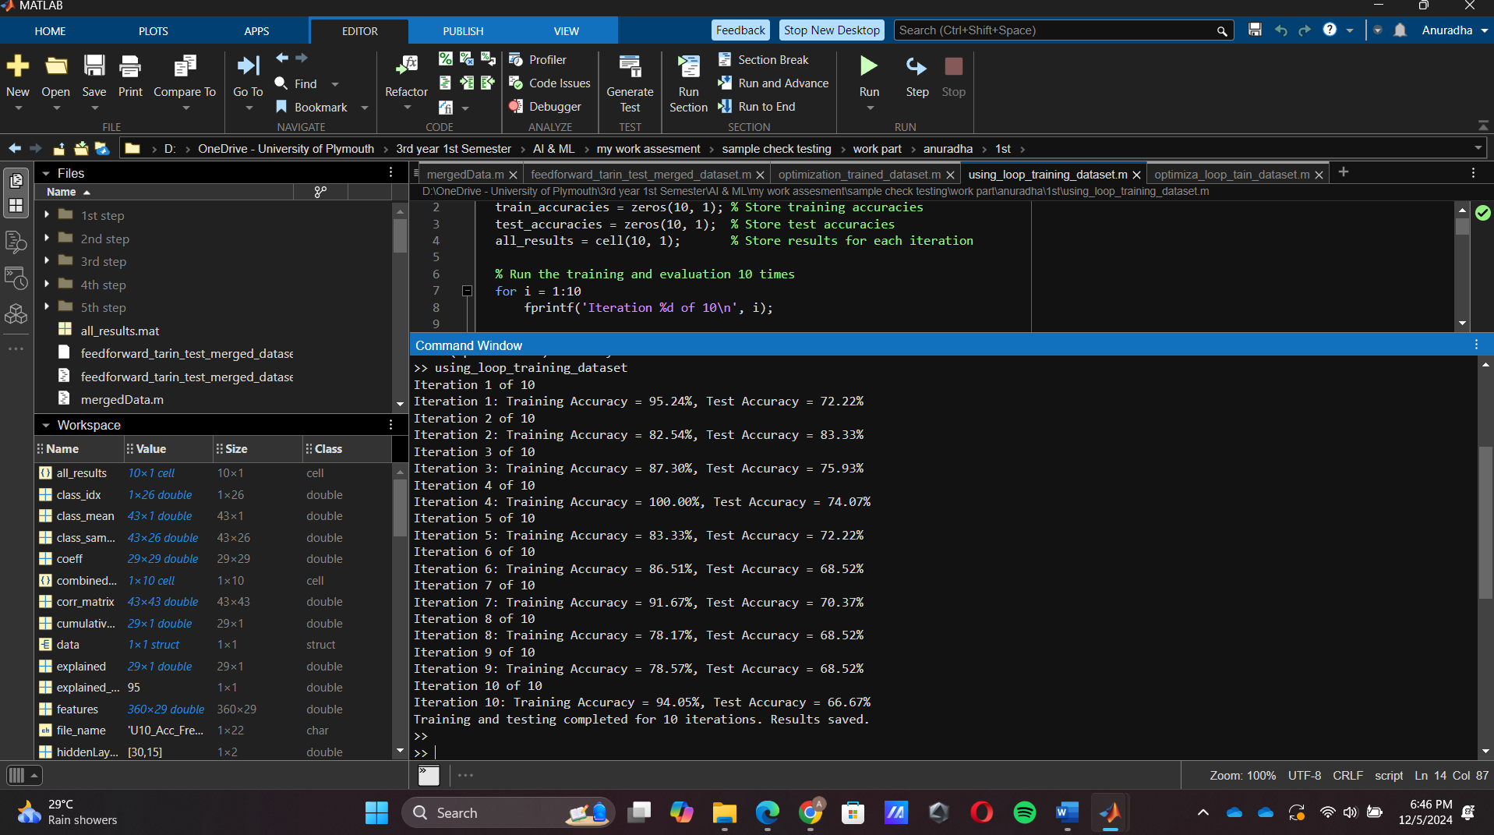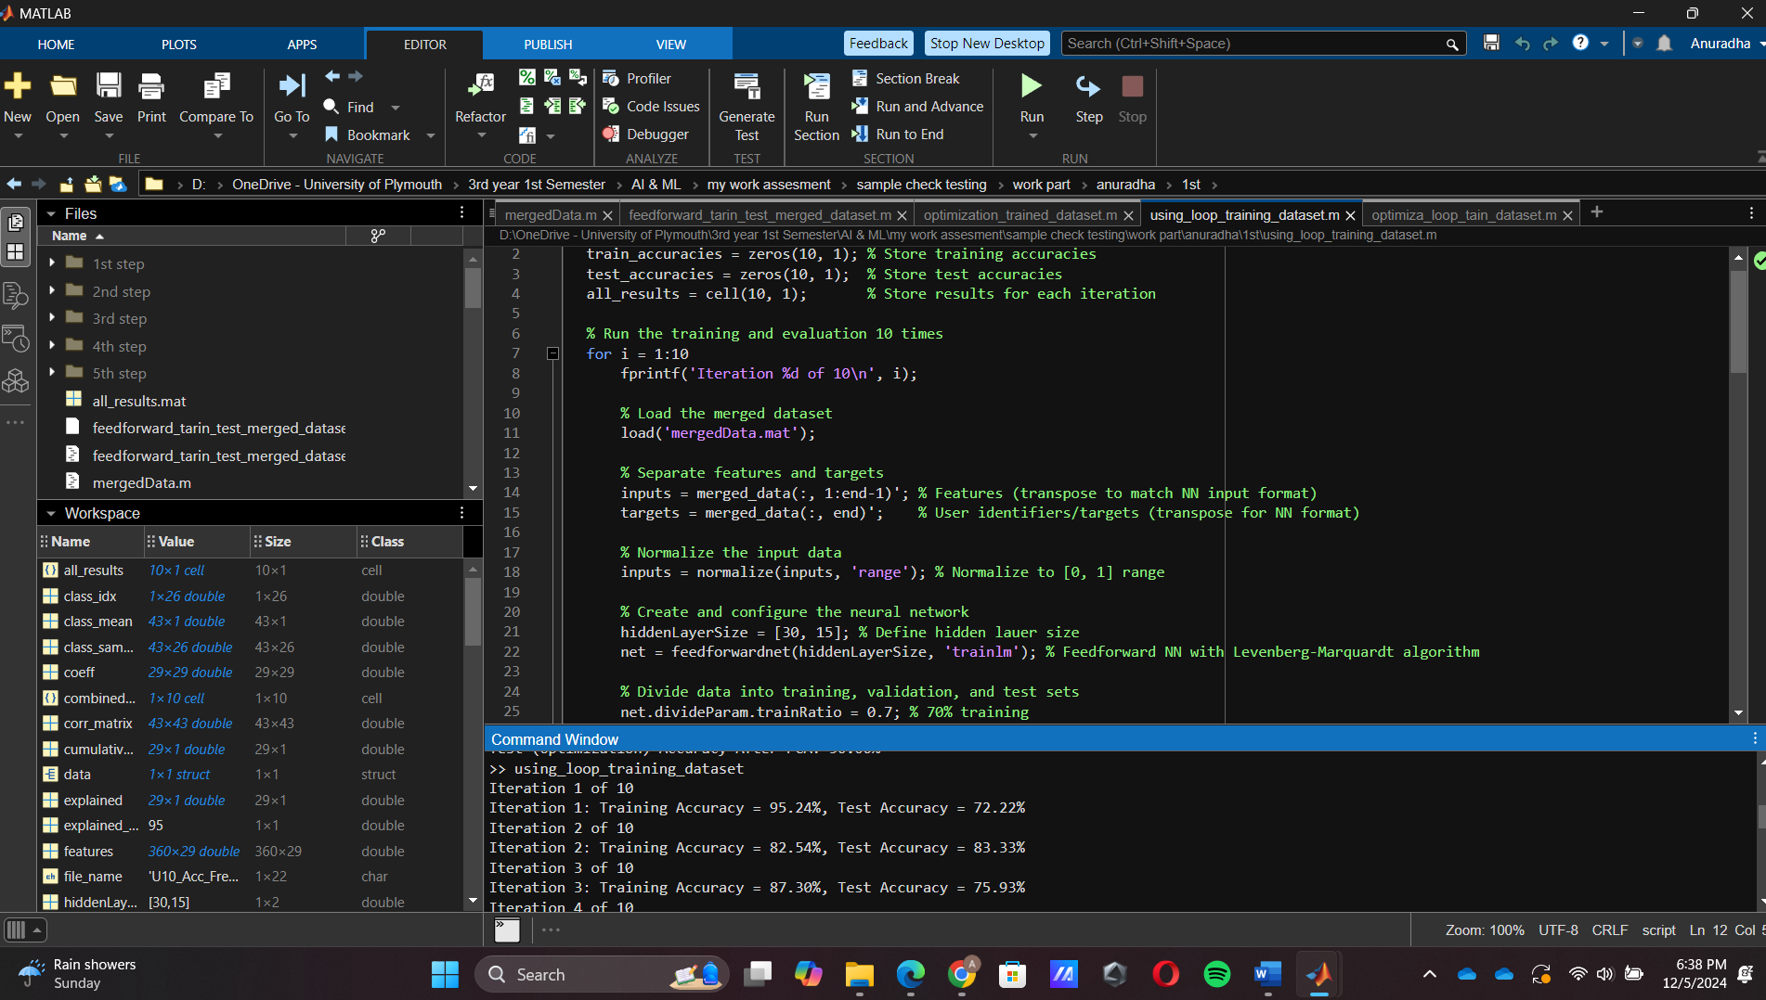

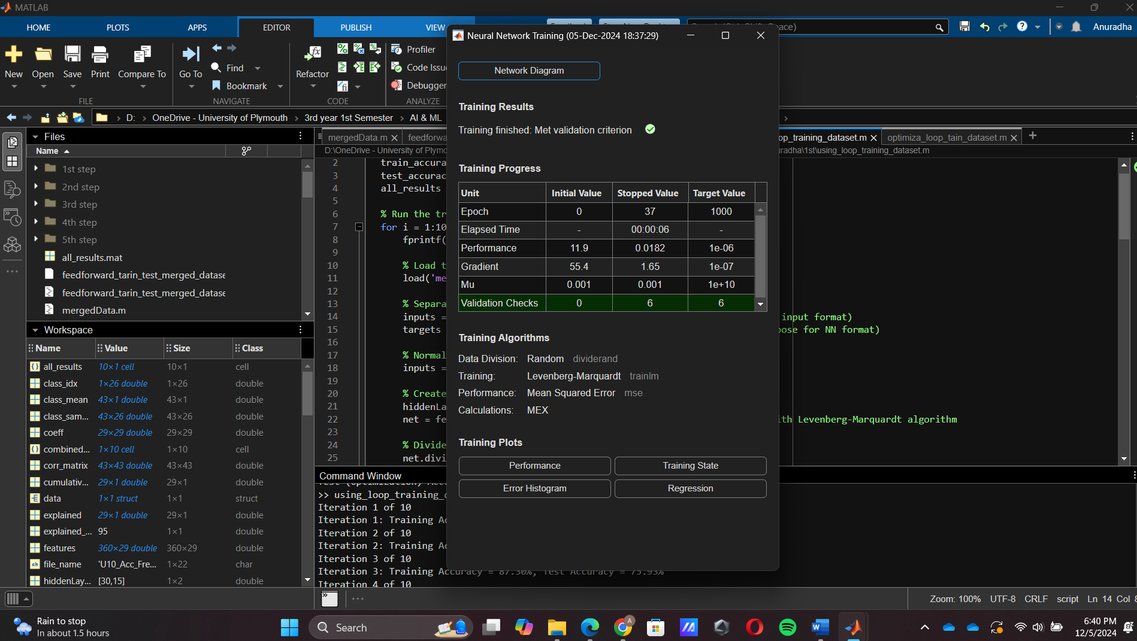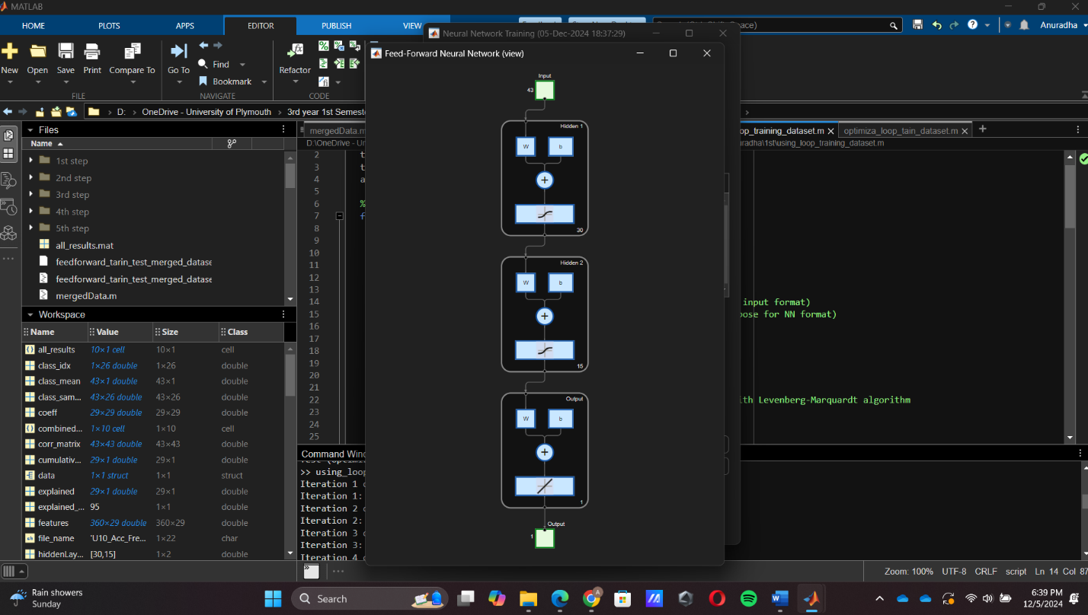

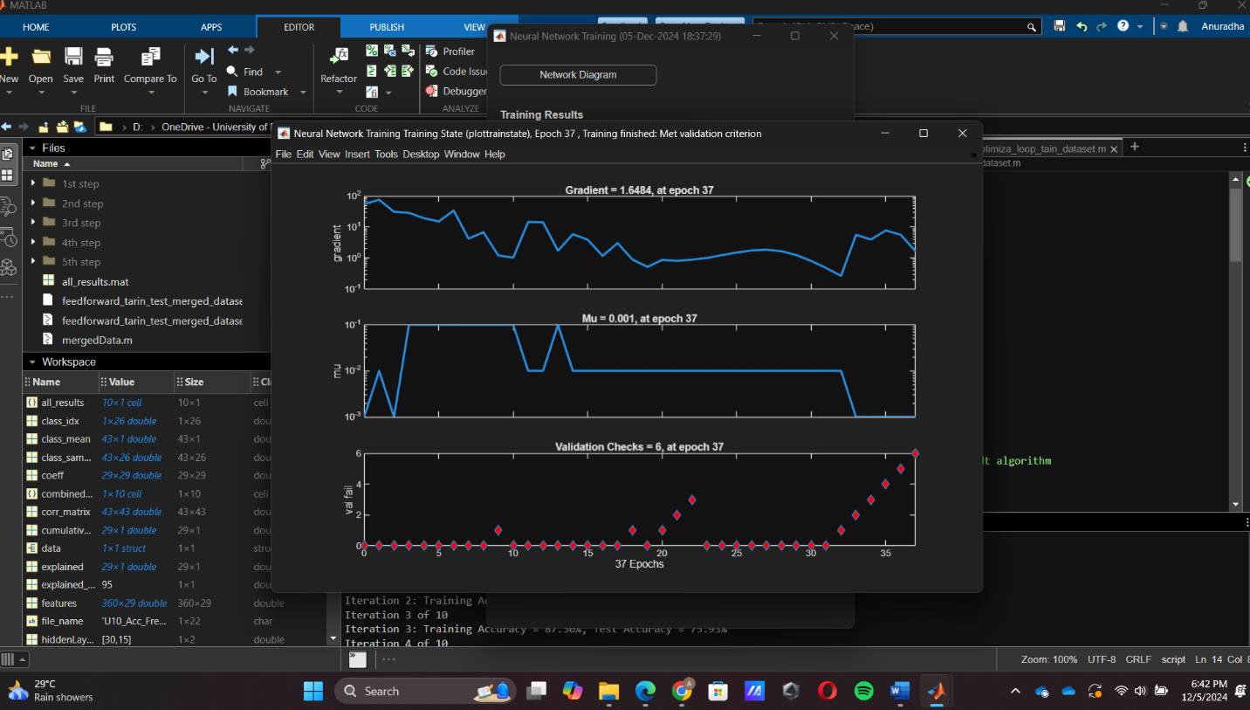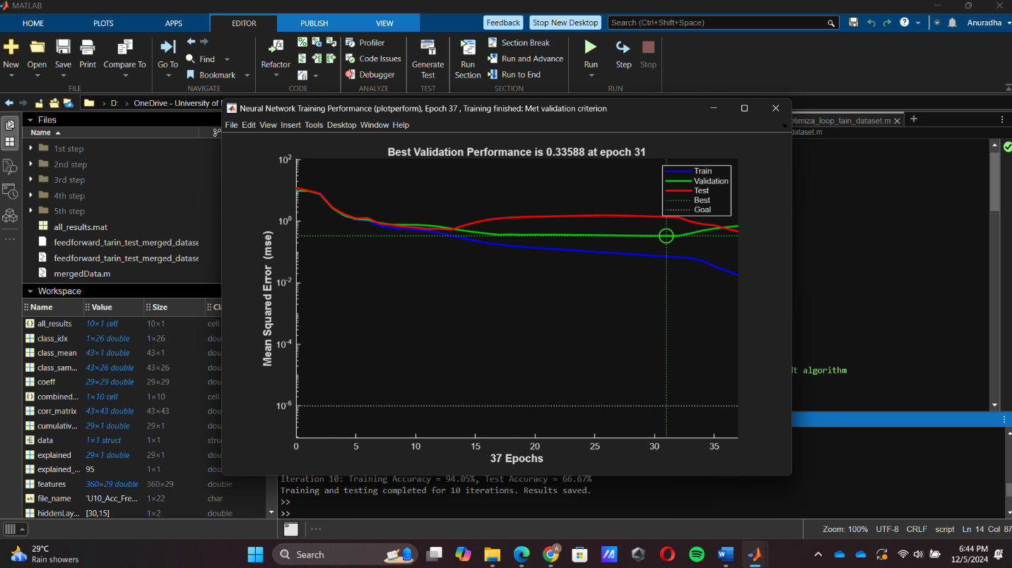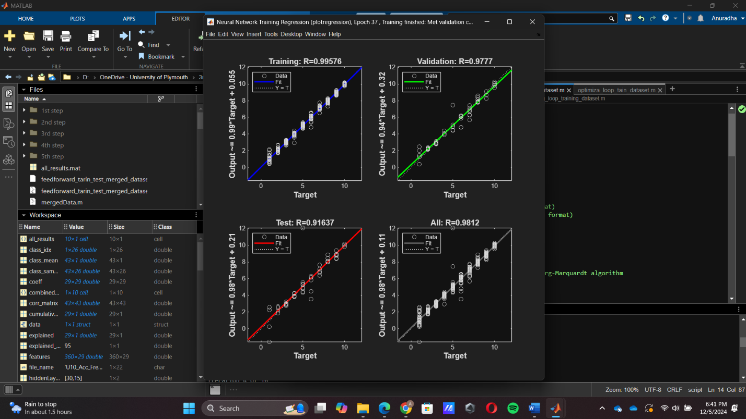

3rd time test

Changes are given below values in code.

Chage training parameters.

% Set training parameters

net.trainParam.epochs = 500; % Maximum number of epochs

net.trainParam.goal = 1e-5; % Performance goal (MSE)

net.trainParam.min_grad = 1e-8; % Minimum gradient

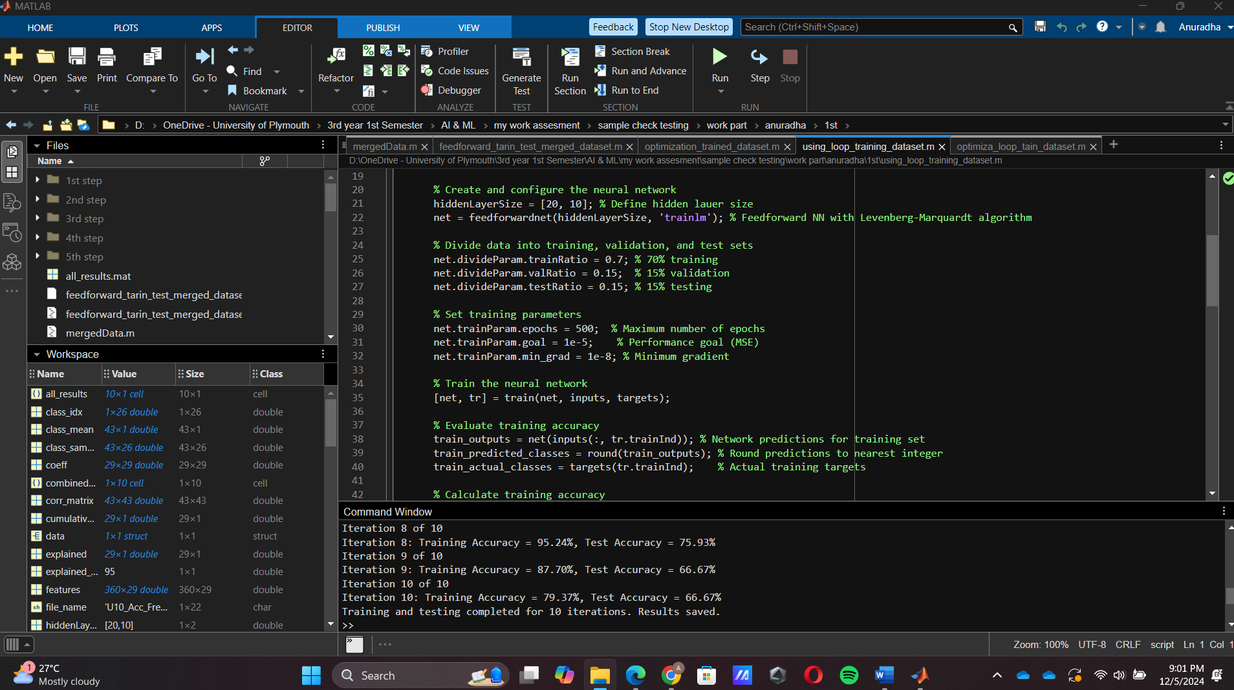

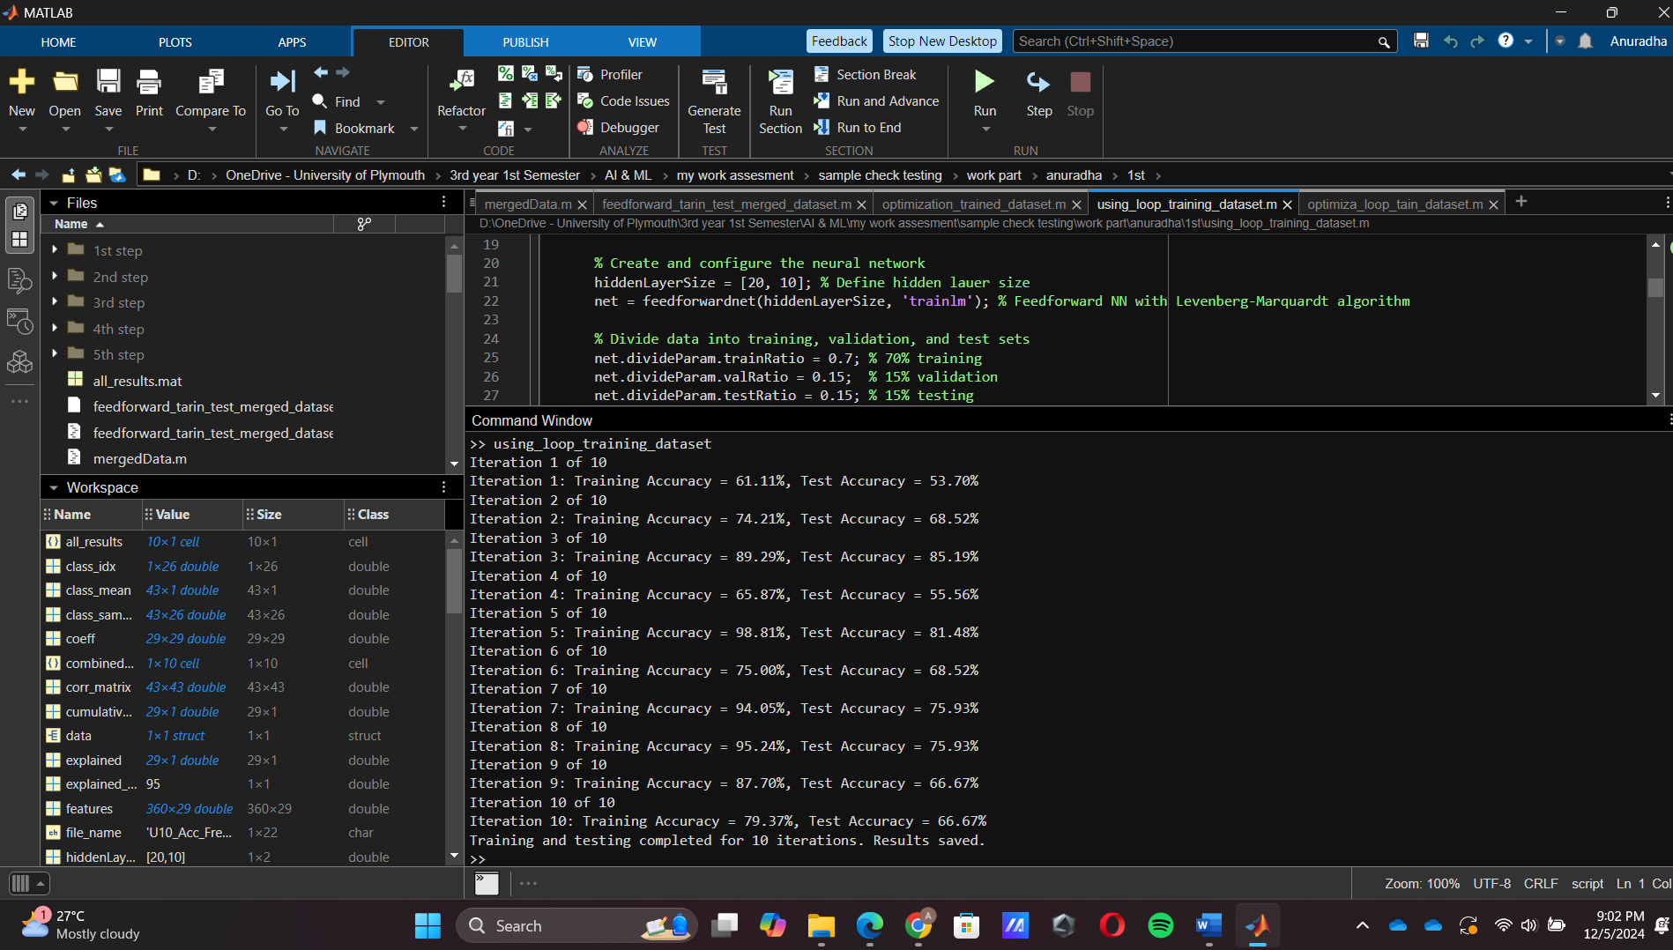

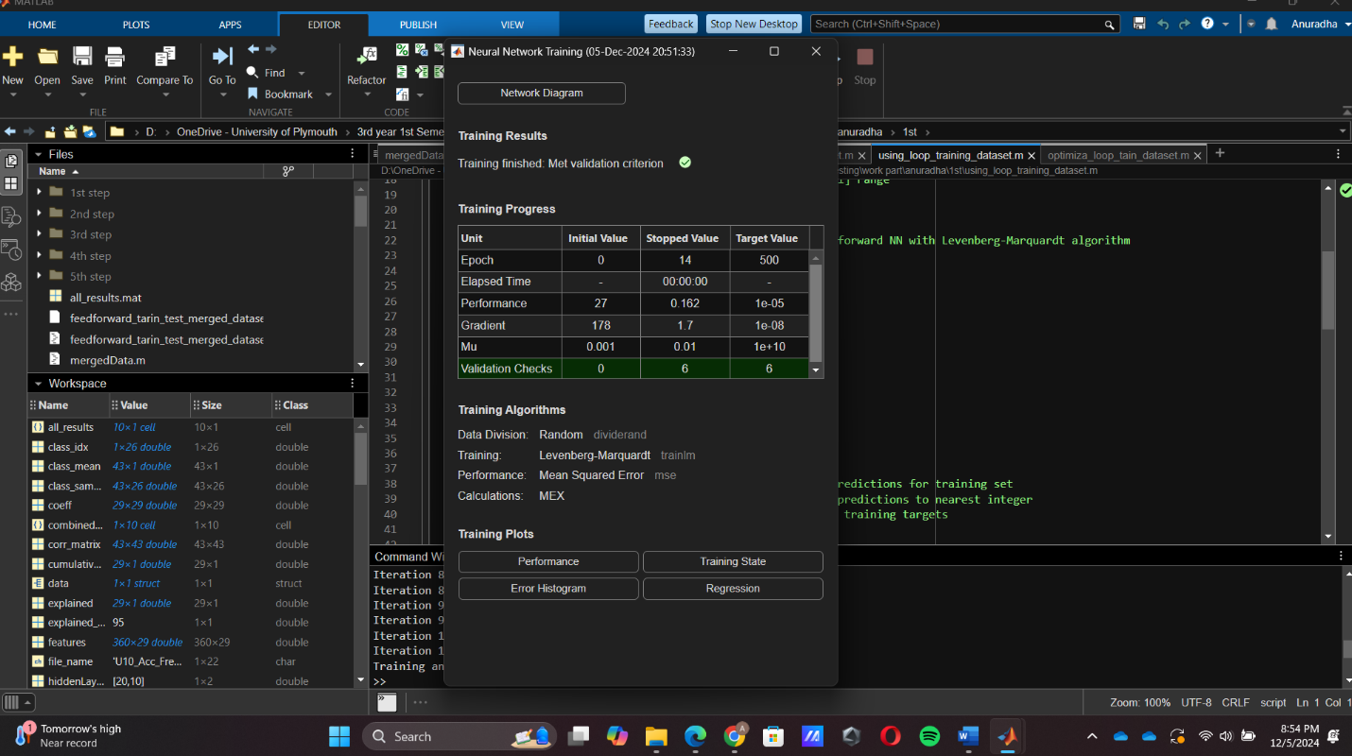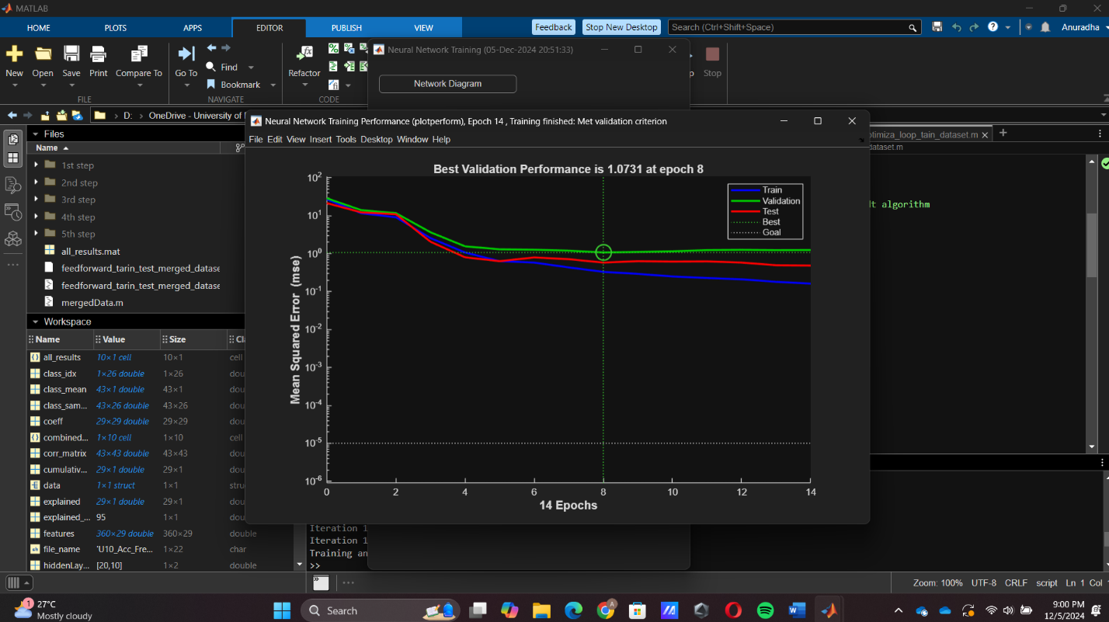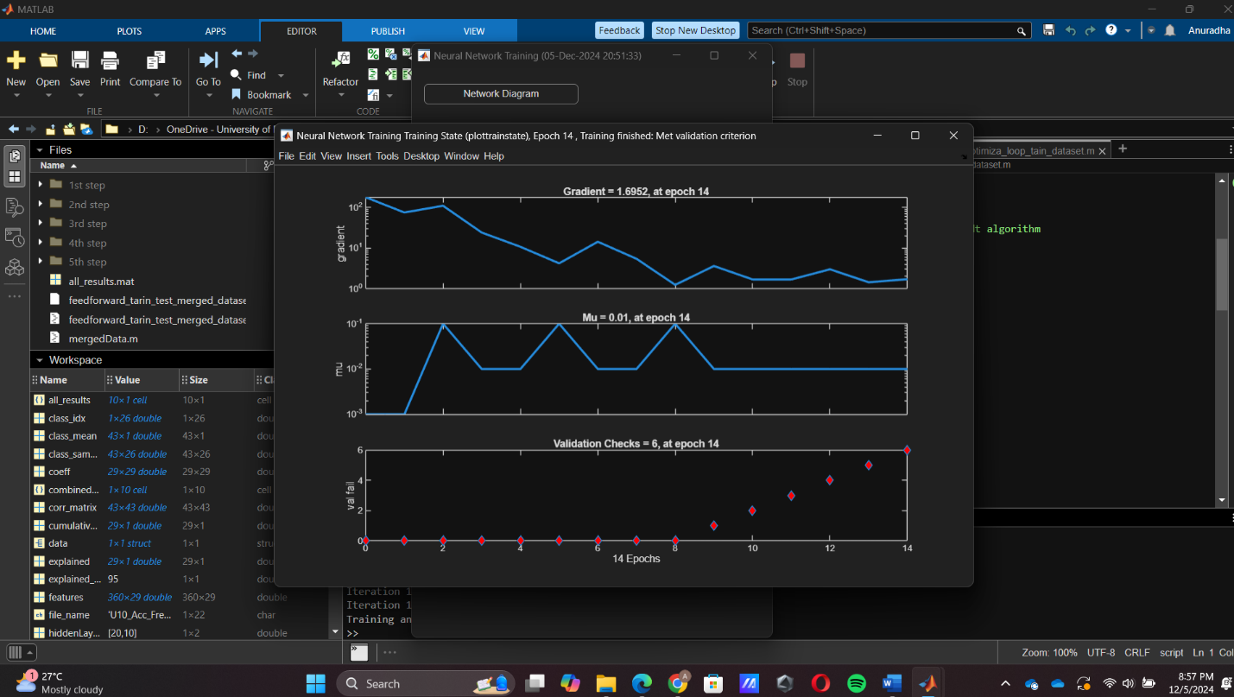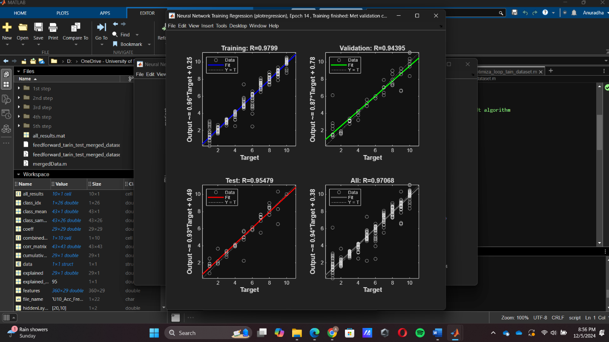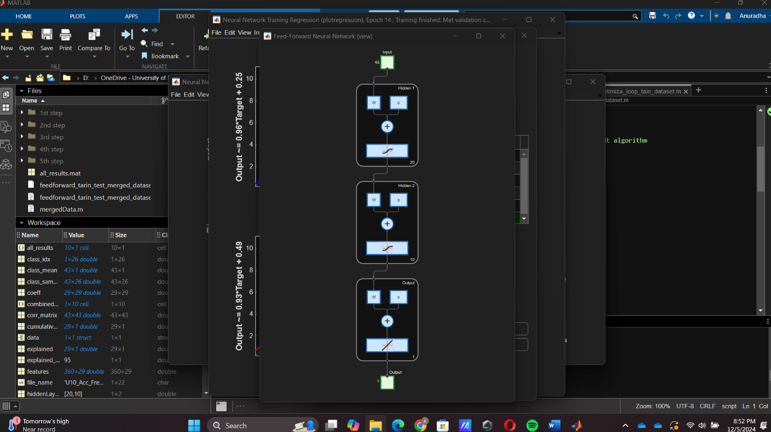

4th time training data set

Change the training, validation, and test sets values.

% Divide data into training, validation, and test sets

net.divideParam.trainRatio = 0.6; % 60% training

net.divideParam.valRatio = 0.2; % 20% validation

net.divideParam.testRatio = 0.2; % 20% testing

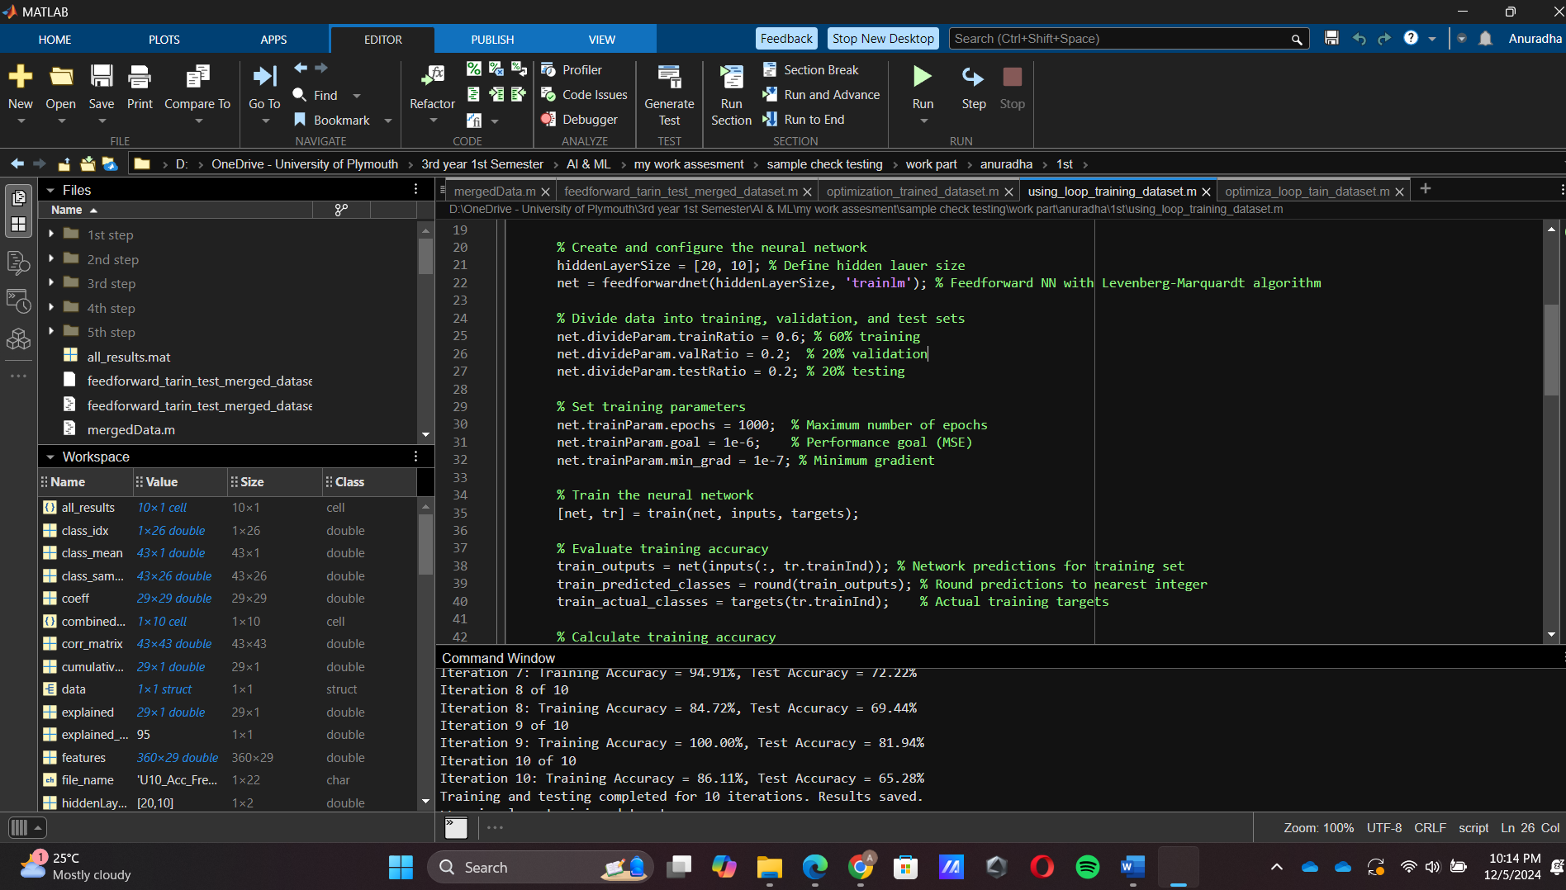

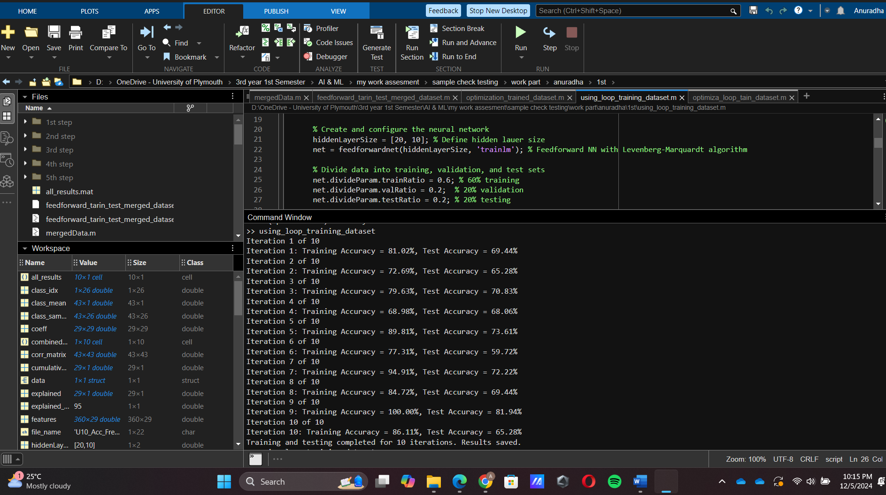

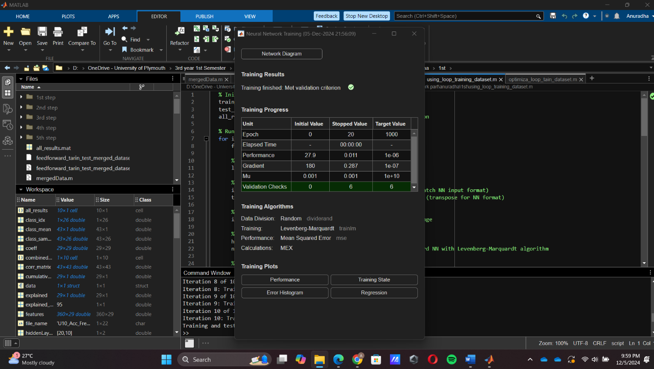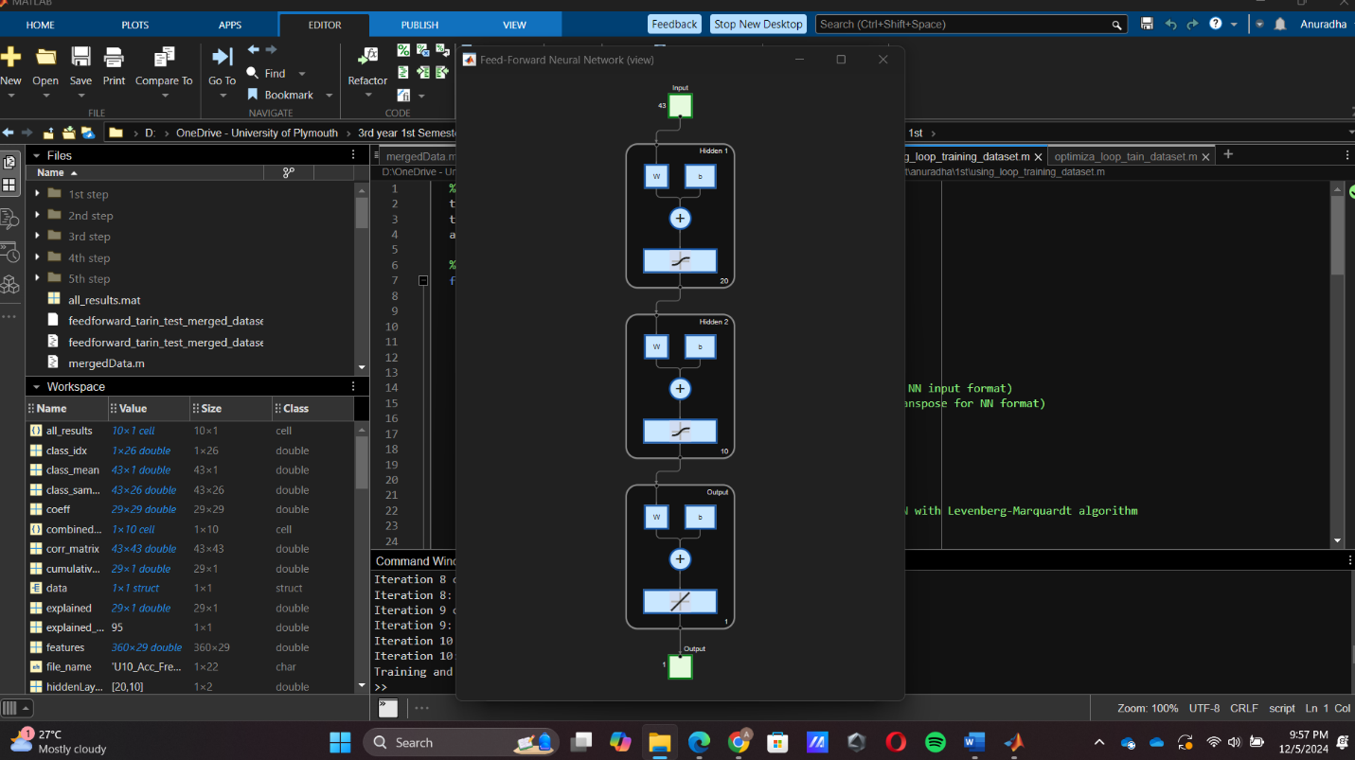

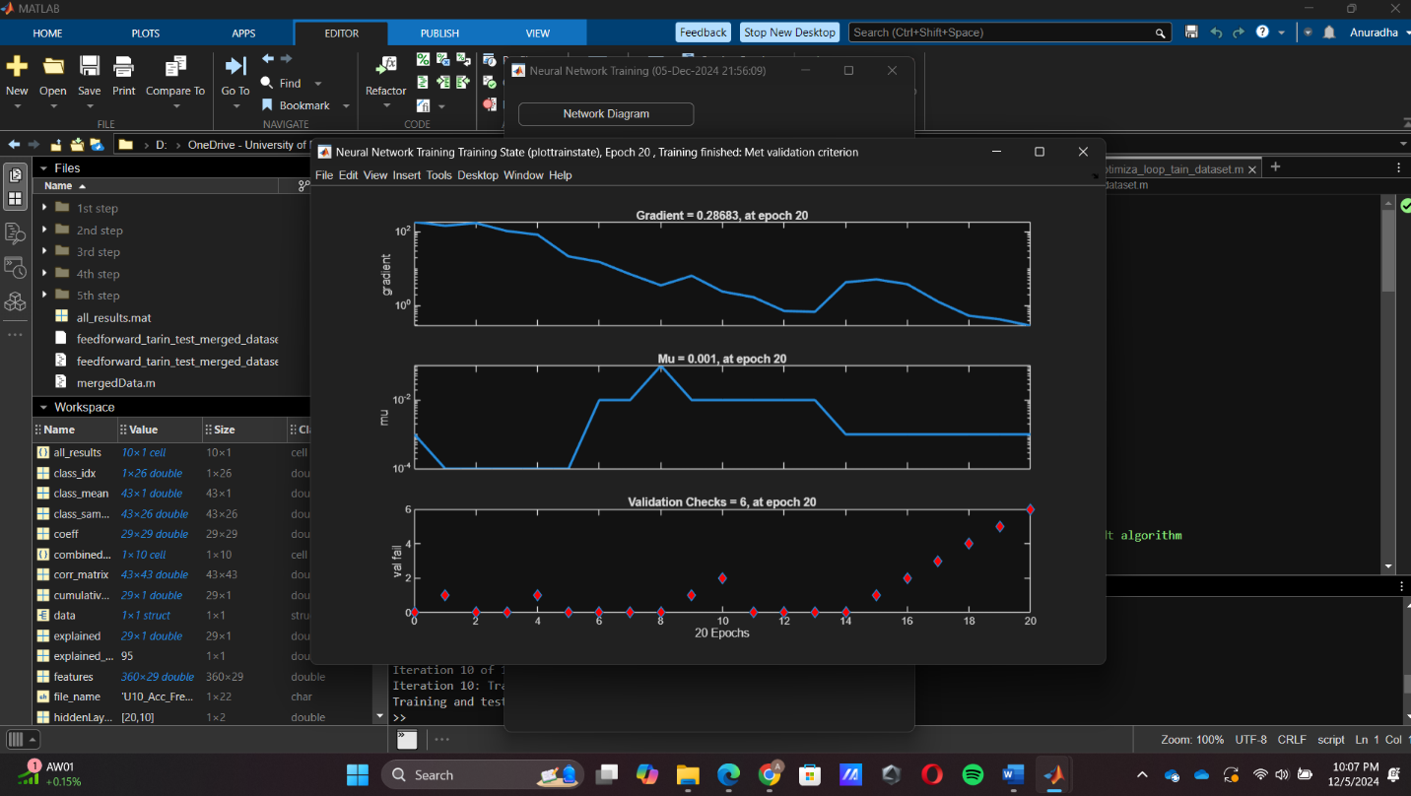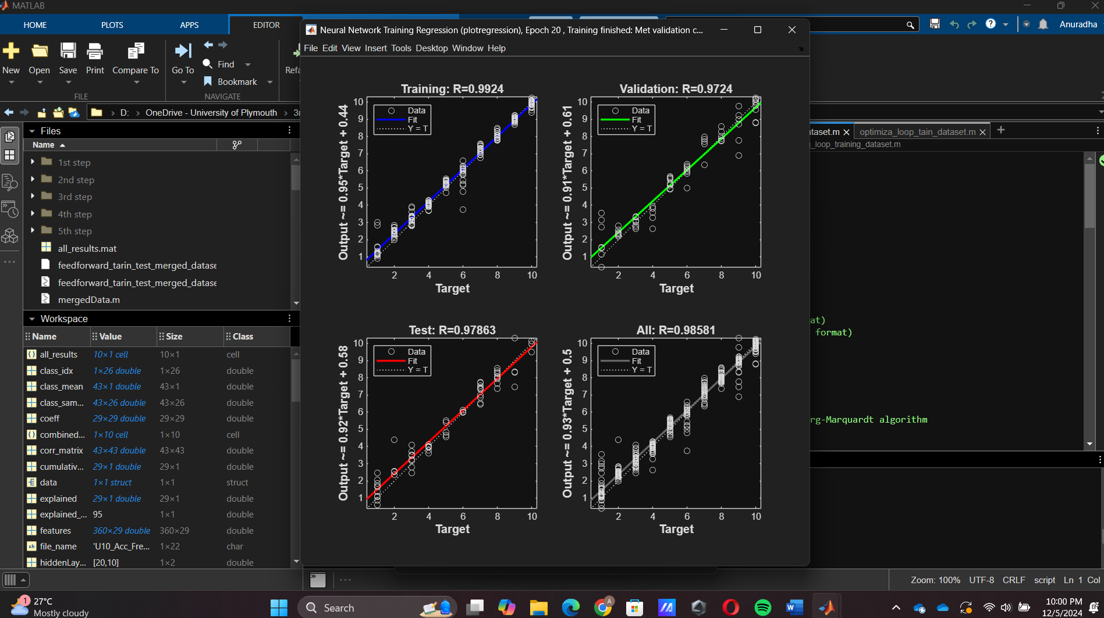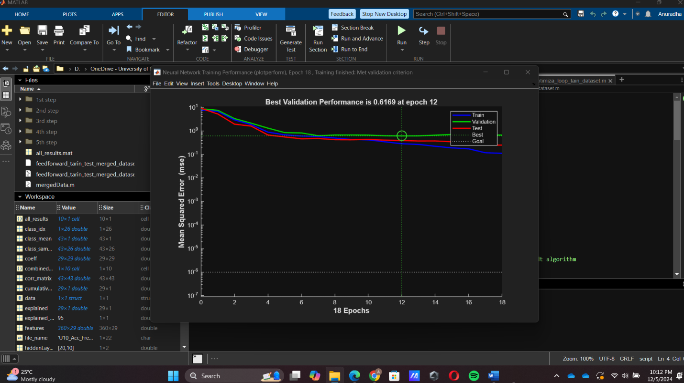

5th time training data set

Change the training, validation, and test sets values, hidden layer size and training parameters.

Changing code steps are given below.

% Create and configure the neural network

hiddenLayerSize = [30, 15]; % Define hidden lauer size

net = feedforwardnet(hiddenLayerSize, 'trainlm'); % Feedforward NN with Levenberg-Marquardt algorithm

% Divide data into training, validation, and test sets

net.divideParam.trainRatio = 0.6; % 60% training

net.divideParam.valRatio = 0.2; % 20% validation

net.divideParam.testRatio = 0.2; % 20% testing

% Set training parameters

net.trainParam.epochs = 500; % Maximum number of epochs

net.trainParam.goal = 1e-5; % Performance goal (MSE)

net.trainParam.min_grad = 1e-8; % Minimum gradient

